CURRICULUM-VITAE
PARVEEN KUMAR 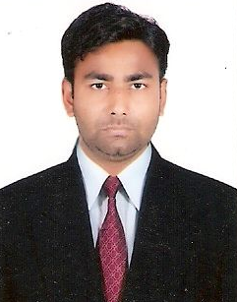
V.P.O. UCHANA, NEAR KARAN LAKE,
DISST. KARNAL (132001)
HARYANA.
PH. NO. +91-89502-61026
e-mail id:- k.panchal61026@gmail.com

OBJECTIVE:

To continuously improve myself through Discipline, Determination and Dedication, towards the benefit of the organization and gain continuous Exposure, Reputation and experience.

PERSONAL DETAILS:

Name: Parveen kumar
Father’s Name: Sh. Sumar Chand
Date of Birth: Jan. 06, 1983
Sex: Male
Marital Status: Married
Language Known: Hindi, English

ACADEMIC QUALIFICATION:

Graduation | Lucknow University | 2005 | 56%
10+2 | H.B.S.E | 2002 | 47%
10th | H.B.S.E | 1999 | 51%
TECHNICAL QUALIFICITION:

- One year Diploma in Computer Software from CMC Computer Center, Karnal.
STRENTH:

- Hard work with smart work.
- Able to work in any environment.
- Punctual and dedicated to work.
- Ability to grasp new things.

PUNCH LINE:

- Positive attitude towards life.

EXPERIENCE:

Working Experience | Origination | Degination | Location
April 2008 to  28 Feb 2013 | HDFC Bank Ltd. | Sales Officer | Karnal
1 April 2013 to  7 Dec 2013 | Yes Bank Ltd. | Senior Sales Officer | Karnal

Job Description-:

- Now Working as BDO in Crisil Ltd.

Job Responsibility-:

- Sourcing new client for BLR Rating.
- Sourcing leads for banker and make good relation with banker.

I here by declare that the above information are complete and correct to the best of my knowledge.

Place: Karnal
Date Parveen Kumar

